On-Farm Living Lab on organic farming
ÖMKi On-Farm Living Lab is testing sustainable solutions in Hungary
A nationwide participatory experimentation network was set up in Hungary in 2012 to improve and develop new organic practices and at the same time boost the transition to agroecology. Farmers and researchers in the ÖMKi On-Farm Living Lab co-design and co-implement field trials and technology tests on sustainable crop and animal management techniques which contribute to the flexibility, sustainability and resilience of farming systems and adaptation of farms in the context of climate change.
The Hungarian Research Institute of Organic Agriculture (ÖMKi) promotes the improvement and more widespread use of organic agriculture in Hungary. One of ÖMKi’s main activities is on-farm research. Their on-farm research network is a system of innovative experiments carried out on over 100 Hungarian organic farms. In 2020 the network was awarded with a ‘Living Lab’ accreditation and admitted to the European Network of Living Laboratories (ENoLL). ‘Living Labs’ facilitate and foster open, collaborative innovation where different stakeholders (such as citizens, farmers, researchers, companies) can co-create solutions in real life settings.
The ÖMKi On-Farm Living Lab was initiated to develop organic farming and disseminate best practices in sustainable agriculture in a range of areas including arable crops, horticulture, apiculture, viticulture and animal husbandry. It is based on active participation of farmers in research and the exchange of professional experiences. The problems to tackle and the solutions to try out are determined together by farmers, researchers and other actors in the value chain, and testing is implemented under diverse conditions.
Ágoston Nobilis, owner of Csoroszlya organic farm, is conducting several experiments in collaboration with the ÖMKi On-farm Living Lab. “It is very inspiring that young researchers, who are truly committed to organic agriculture and the conservation of biodiversity, provide us with practical advice through on-farm collaboration. These connections and the continuous exchange of our experiences also leads us towards better results.”
The ÖMKi On-Farm Living Lab regularly organises workshops, field days and conferences to bring together farmers and present opportunities for new national or EU-funded projects and to share the practical results of the research network. Results are also shared through technical publications, videos, practice abstracts and online articles. Farmers can join the network on a voluntary basis.
One of the projects within the ÖMKi On-Farm Living Lab aimed at reintroducing landrace tomatoes into agricultural production. Zoltán Dezsény, a farmer who participated in this experiment says: “Tomato landraces are heritage cultivars and are not common in Hungarian farming. However, they contribute to agro-biodiversity, facilitate climate adaptation, and resilience through genetic diversity and their high value can help farmers achieve a better livelihood.” Zoltán Dezsény continues “As an enthusiastic organic farmer, I gladly participate in research, workshops and professional meetings organised by ÖMKi. These not only provide possibilities to try out new practices, but also create opportunities for mutual exchange of experiences with other farmers and professional networking.”
Dóra Drexler, ÖMKi’s director, concludes “Within the framework of the European Green Deal, agro-ecological methods are becoming more and more important, in 2022, we will work on the establishment of a European pilot network of Living Labs. The ÖMKi On-farm Living Lab is helping to find innovation opportunities to contribute to the sustainability and flexibility of farming systems, helping farmers to adapt to climate change at a local level, and facilitating the transition of Hungarian agriculture to agroecology. We therefore want to share our experience with other countries.”

Background information
The size of the area under organic cultivation in Hungary has doubled since 2016, representing around 6% of total agricultural land in 2020 (for the EU as a whole, this was 9% in 2020) - Eurostat. According to the recently published national Organic Action Plan, Hungary has a target to achieve 10% by 2027.

Project information
Contact: Dóra Drexler dora.drexler@biokutatas.hu, +36 1 244 8358

- https://biokutatas.hu/en/page/show/omki-on-farm-living-lab
- https://biokutatas.hu/en/page/show/onfarm
- https://www.youtube.com/channel/UC15_t-S-sJNDdxvFZQfJD4w
- https://enoll.org/network/living-labs/?livinglab=omki-on-farm-living-lab#description

Project photos
Click on the pictures to download the high resolution versions. The pictures are free for use, please mention the copyright.

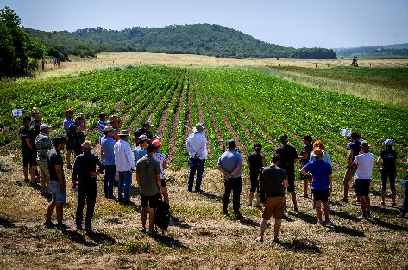 | 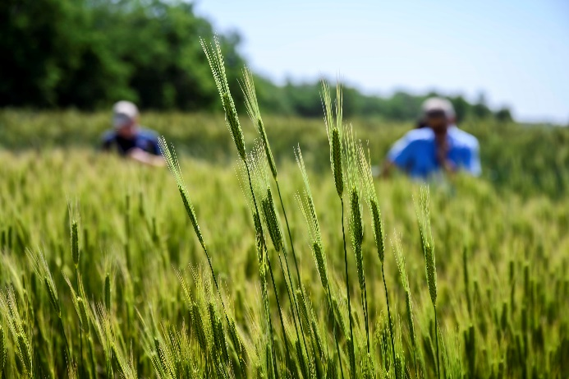
The ÖMKi On-Farm Living Lab regularly organises workshops, field days and conferences to bring together farmers and present opportunities for new national or EU funded projects and to share the practical results of the research network. Results are also shared through technical publications, videos, practice abstracts and online articles. Farmers can join the network on a voluntary basis.© ÖMKi | ökológiai mezőgazdasági kutatóintézet

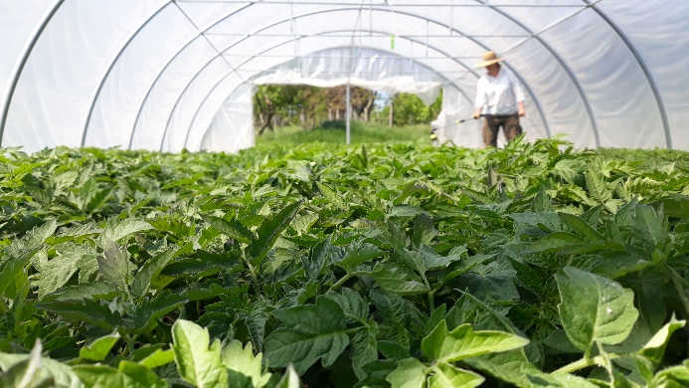 | 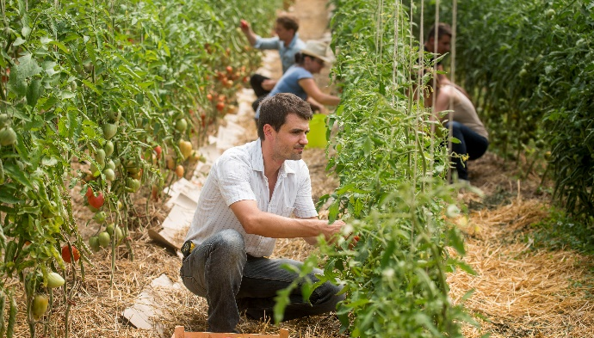
The ÖMKi On-Farm Living Lab’s on-farm research network is a system of innovative experiments carried out on over 100 Hungarian organic farms..© ÖMKi | ökológiai mezőgazdasági kutatóintézet

More information on organic farming

EU Organic Action Plan
As part of its ‘Farm to Fork’ strategy, the EU emphasises the role of organic agriculture in a sustainable food system and aims at 25% of the EU’s agricultural land under organic management by 2030. To achieve this target and to help the organics sector reach its full potential, the Commission is putting forward an action plan for organic production in the EU.

EIP-AGRI Workshop on conversion to organic farming
On 22-23 June 2022, the European Commission with the support of the EIP-AGRI Support Facility, organised the EIP-AGRI workshop ‘Conversion to organic farming: innovative approaches and challenges’ in Florence, Italy. The workshop focussed on exchanging knowledge and sharing innovative, inspirational practices that can support farmers in successful conversion to organic agriculture. Participants exchanged ideas and experiences with innovative projects and stakeholders along the value chain, and discussed future research needs in the field of organic farming and conversion.

EIP-AGRI activities
- EIP-AGRI Focus Group Organic farming - Optimising arable yields
- EIP-AGRI workshop ‘Organic is Operational’
- EIP-AGRI workshop ‘Conversion to organic farming’

EIP-AGRI publications

- EIP-AGRI factsheet Organic Farming (EN – FR – PT)
- EIP-AGRI brochure Innovative solutions for organic farmers in the EU - Optimising arable yields (EN – PO – PT)
- Operational Groups represented at the EIP-AGRI workshop ‘Organic is Operational’
- EIP-AGRI brochure ‘Organic is Operational’

The EIP-AGRI network supports organic farming by promoting and sharing innovative practices.
Read the EIP-AGRI Newsletter from June 2020 which was dedicated to organic farming. For all relevant EIP-AGRI network activities see the spotlight page on organic farming.

Horizon 2020 multi-actor projects
- OK-Net-Arable - Organic Knowledge Network Arable: website - CORDIS (Thematic network – 03/2015-02/2018)
- CERERE - CEreal REnaissance in Rural Europe: embedding diversity in organic and low-input food systems: website - CORDIS (Thematic network – 11/2016-10/2019)
- TRUE - Transition paths to sustainable legume based systems in Europe: website - CORDIS (04/2017-03/2021)
- Diverfarming - Crop diversification and low-input farming across Europe: from practitioners engagement and ecosystems services to increased revenues and chain organisation: website - CORDIS (05/2017-04/2022)
- DiverIMPACTS - Diversification through Rotation, Intercropping, Multiple cropping, Promoted with Actors and value-Chains Towards Sustainability: website - CORDIS (06/2017-05-2022)
- LEGVALUE - Fostering sustainable legume-based farming systems and agri-feed and food chains in the EU: website - CORDIS (06/2017-05/2021)
- LIVESEED - Improve performance of organic agriculture by boosting organic seed and plant breeding efforts across Europe: website - CORDIS (06/2017-05/2021)
- OK-Net Ecofeed - Organic Knowledge Network on Monogastric Animal Feed: website - CORDIS (Thematic network – 01/2018-12/2020)
- BRESOV - Breeding for Resilient, Efficient and Sustainable Organic Vegetable production: website - CORDIS (05/2018-04/2023)
- ECOBREED - Increasing the efficiency and competitiveness of organic crop breeding: website- CORDIS (05/2018-04/2023)
- Organic-PLUS - Pathways to phase-out contentious inputs from organic agriculture in Europe: website - CORDIS (05/2018-04/2022)
- RELACS - Replacement of Contentious Inputs in organic farming Systems: website - CORDIS (05/2018-04/2022)
Multi-actor projects are projects in which end users and multipliers of research results such as farmers and farmers’ groups, advisers, enterprises and others, are closely cooperating throughout the whole research project period.
Thematic networks are multi-actor projects which collect existing knowledge and best practices on a given theme to make it available in easily understandable formats for end-users such as farmers, foresters, advisers etc.

Operational Groups

69 Operational Groups working on organic farming are available in the EIP-AGRI Operational Groups database (update 11 May 2022)
- Austria: 4
- Belgium: 3
- France: 6
- Germany: 22
- Ireland: 1
- Italy: 11
- Latvia: 1
- The Netherlands: 4
- Portugal: 2
- Spain: 11
- UK: 4

Inspirational ideas
- Market gardening – Austria
- Organic growers harvest ancient grain varieties - Hungary
- Supporting new entrants into organic dairy sheep farming - Greece
- Perfumes for pests – Denmark, Latvia, Sweden, UK
- Dealing with pests from the air - France
- Cloud technology to safeguard integrity of the organic sector EU
- Winter harvest- supporting the development of organic winter growing - Austria
- Feeding pigs and poultry: tips for a 100% organic diet – Austria, Denmark, Finland, France, Germany, Lithuania, Netherlands, Sweden, UK, Switzerland.
- Improving chicken value chains- an Operational Group in Germany - Germany
- Local food networks inspiring people to take up organic farming - Spain
- Finding new in the old, reviving former links between forest and agricultural land - Spain
- Goats in good company - Italy
- From great soil comes great food – a farmers’ story - France
- Improving welfare for cows…and farmers – Denmark
- Aronia and other organic superberries in Centre-Val de Loire - France

The CAP of the Future
The reform of the Common Agricultural Policy (2023-2027) has been formally approved end November 2021. Find all information on the new CAP on the European Commission website.

Innovation & knowledge exchange | EIP-AGRI
The European Innovation Partnership 'Agricultural Productivity and Sustainability' (EIP-AGRI) has been launched in 2013 by the European Commission in a bid to promote rapid modernisation of the sectors concerned, by stepping up innovation efforts. The EIP-AGRI aims to foster innovation in the agricultural and forestry sectors and in rural areas by bringing research and practice closer together – in research and innovation projects as well as via the EIP-AGRI network. Also grassroots ideas from farmers get developed into innovations through the so-called Operational Group innovation projects. The EIP-AGRI aims to streamline, simplify and better coordinate existing instruments and initiatives, and complement them with actions where necessary. More information at the ‘About section’ of the EIP-AGRI website.

EIP-AGRI Operational Groups
- 98 Rural Development Programmes provide support to innovative EIP Operational Group projects *
- Over 3200 Operational Groups are planned to be established under the approved RDPs (2014 – 2020)
- More than 2400 Operational Groups projects have been selected for funding and are currently ongoing (or already finished)*. Member States will still start more Operational Group projects which may run until 2025 (under current transitional rules for EU rural development programmes). Find information on all of them in the EIP-AGRI database.

* Information officially submitted to the European Commission by RDP Managing Authorities (November 2020)

EIP-AGRI Operational Groups are groups of people who work together in an innovation project funded by Rural Development Programmes (RDPs). They bring together partners with complementary knowledge. The composition of the group will vary according to the theme and specific objectives of each project. Farmers, advisors, scientists, businesses or other relevant partners work together to find practical solutions for specific problems or opportunities for European farmers and foresters. Farmers and foresters need to cooperate throughout the project to ensure that the innovative solutions are practical and likely to be quickly applied in the field. Read the basic principles. Innovation support services (including advisors with a focus on innovation), and in particular innovation brokering, can therefore play a crucial role in getting worthwhile projects off the ground by facilitating contacts.

Check out the section on the EIP-AGRI website dedicated to 'Operational Groups', including:
- more than 2400 Operational Groups available in the database
- detailed information on how to set up Operational Groups, on supporting networks and relevant EIP-AGRI seminars and workshops
- links to results and contact details of ongoing Operational Groups in the EIP-AGRI database
- a list of all RDP Managing Authorities

EIP-AGRI videos
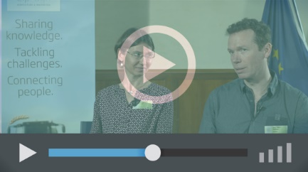
Operational Groups – first experiences | Operational Groups – collaborate to innovate
 | 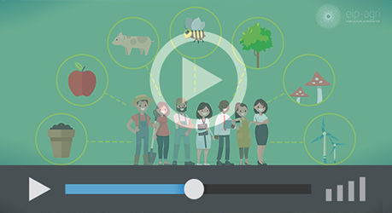
Innovation Support Services, supporting innovation in EU farming and forestry | EIP-AGRI Focus Groups, sharing knowledge to inspire innovation
AKIS: building effective knowledge flows across Europe

EIP-AGRI, 7 years of innovation

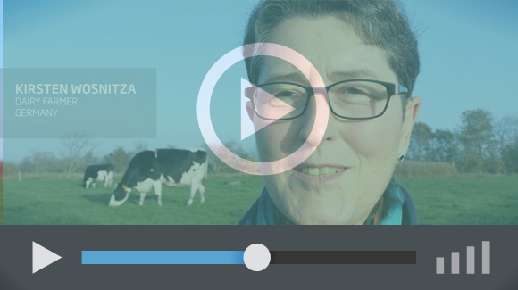 |  | The enthusiasm of the EIP-AGRI network members is essential to the success of the EIP-AGRI, and in ensuring that everyone can benefit. Watch this EIP-AGRI video to hear researchers, farmers, advisors, Managing Authorities and National Rural Networks explain how the EIP-AGRI has helped them over the past 7 years.
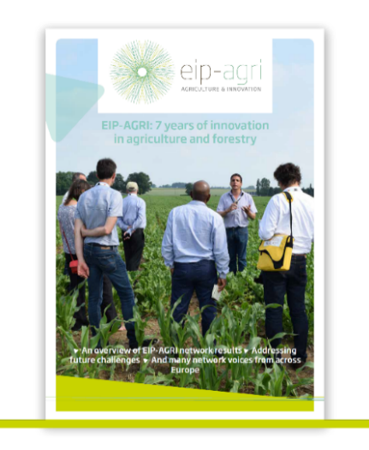 | Since 2013, the EIP-AGRI has been promoting interactive innovation to make EU agriculture and forestry more sustainable, productive, and fit for the future. This report shows how the EIP-AGRI network has grown into a thriving network. Read the report

