Press article long article

Biodegradable mulch films to reduce plastic footprint in agriculture

Spanish Operational Group investigates new techniques to accelerate degradation of mulch film

Plastics are widely used in agriculture, but they create challenges for the environment. About 80% of the plastic waste is generated by plastic mulch films. Their waste collection is difficult and significant parts stay in the fields, generating microplastics that end up in rivers and oceans. A Spanish Operational Group (OG) encourages farmers in their region to use biodegradable mulch films and provides solutions for accelerating the degradation progress.

Operational Group AColchados BioDegradables (GO-ACBD) is coordinated by Abelardo Hernandez from the Association of Fruit and Vegetable Producers-Exporters (Proexport) based in the region of Murcia. He explains why they decided to set up this OG. Abelardo: “Some years ago, several growers came to us looking for a solution to deal with plastic debris in their fields. The growers told us that every time a crop had been harvested and the soil was ploughed, many small pieces of the mulch film could be found mixed in with the soil. GO-ACBD was launched to find a solution for this problem.”

The consortium includes five well-known agricultural companies and together they work with two research centres specialised in biodegradable mulch. The OG partners assessed the problem and it became clear that the solution had to be addressed in two ways. First, by reducing the amount of non-biodegradable debris. This could be done by encouraging farmers not to use polyethylene films under 15 micrometre thickness, which are extremely difficult to remove from the soil. Using more expensive biodegradable mulch films instead has environmental and economic benefits because they do not have to be removed from the soil at the end of the crop cycle. They can be ploughed into the ground where they will break down and leave no debris. The second part of the solution, is reducing the time that biodegradable mulch film remains in the soil. According to standard EN-17033, mulch is called biodegradable when it has a biodegradation threshold of 90% in 2 years. For many farmers this is too long as one crop lasts only 3-6 months in the field. Therefore, the OG has been trying to speed up the degradation process and synchronise it with the crop life-cycle. Even biodegradable mulch-films need right conditions and time to disappear completely.

Abelardo: “So far, we have discovered that in order to increase the speed and level of the degradation of biodegradable-mulch film, it must be ploughed into the soil at about 25cm. At this depth there is enough humidity and organic material to ensure microbial activity. After having ploughed the film into the soil, we need to introduce a second crop to get a sufficient level of degradation. This second crop provides extra humidity and organic material, which boosts the microorganisms involved in the degradation process.”

The project is about to finish at the end of 2020, but there are still remaining questions. Therefore, the project partners, with the addition of some new partners, are preparing another project proposal. Abelardo: “In the second project we aim to speed up the degradation using the soil native microorganisms without the need for a second crop.”

Press article short article

Biodegradable mulch films to reduce plastic footprint in agriculture

Spanish Operational Group investigates new techniques to accelerate degradation of mulch film

Plastics are widely used in agriculture, but they create challenges for the environment. About 80% of the plastic waste is generated by plastic mulch films. Their waste collection is difficult and significant parts stay in the fields, generating microplastics that end up in rivers and oceans. A Spanish Operational Group (OG) encourages farmers in their region to use biodegradable mulch films and provides solutions for accelerating the degradation progress.

Operational Group AColchados BioDegradables (GO-ACBD) is coordinated by Abelardo Hernandez from the Association of Fruit and Vegetable Producers-Exporters (Proexport) based in the region of Murcia.

The consortium includes five well-known agricultural companies and together they work with two research centres specialised in biodegradable mulch. Abelardo: “The OG partners assessed the problem and it became clear that the solution had to be addressed in two ways. First, by reducing the amount of non-biodegradable debris. This could be done by encouraging farmers not to use polyethylene films under 15 micrometre thickness. The second part of the solution, is reducing the time that biodegradable mulch film remains in the soil.”

Abelardo: “So far, we have discovered that in order to increase the speed and level of the degradation of biodegradable-mulch film, it must be ploughed into the soil at about 25cm. At this depth there is enough humidity and organic material to ensure microbial activity. After having ploughed the film into the soil, we need to introduce a second crop to get a sufficient level of degradation. This second crop provides extra humidity and organic material, which boosts the microorganisms involved in the degradation process.”

Background information

Watch the Operational Group project movieclip
Video & script: Operational Group ACBD
Editing: EIP-AGRI Service Point

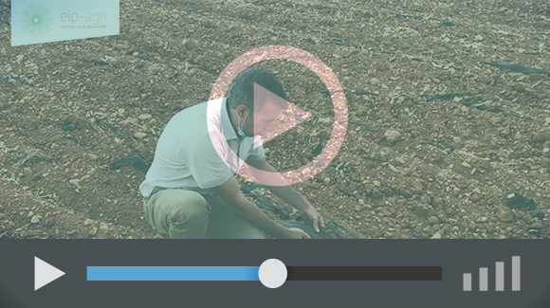

In 2018, the standard EN-17033, for biodegradable mulch films was released. It stated that biodegradable mulch films should have a biodegradation threshold of 90% in 2 years, to be called biodegradable. For many farmers this is too long as one crop lasts only 3-6 months in the field. Therefore, the Operational Group ABCD has been trying to speed up the degradation process and synchronise it with the crop life-cycle. The remaining share of the bio-mulch is converted into biomass, which no longer contains any plastic.

Project information
Contact person: Mr. Abelardo Hernandez - ahernandez@proexport.es - 0034 968 27 17 79

- www.acolchadosbiodegradables.es
- Operational Group project webpage in the EIP-AGRI database

EIP-AGRI contact
Ina Van Hoye
Communication officer
EIP-AGRI Service Point
ina.vanhoye@eip-agri.eu
+32 486 90 77 43

Pictures
Click on the pictures to download them. The pictures are free for use. Please mention copyright: Operational Group ACBD

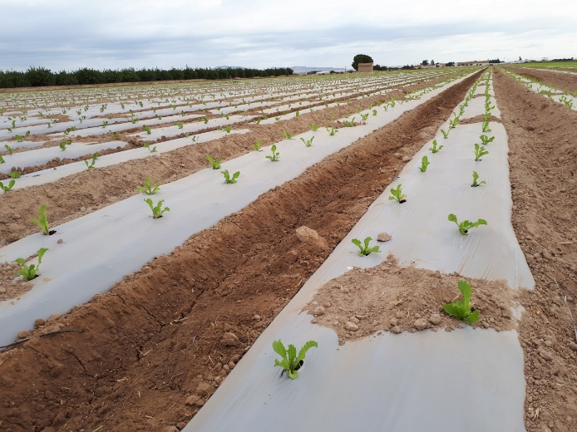 | 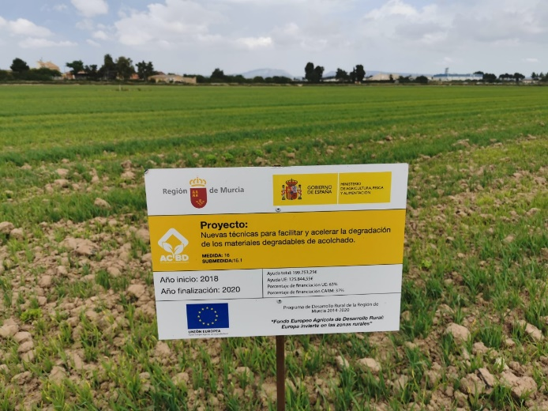
Operational Group GO-ACBD was launched to find a solution to deal with plastic debris in the farmers’ fields: every time a crop had been harvested and the soil was ploughed, many small pieces of the mulch film could be found mixed in with the soil.

More information on reducing the plastic footprint

The experts from the EIP-AGRI Focus Group Reducing the plastic footprint of agriculture cover the question ‘How to reduce the use of plastic in agricultural holdings through recycling and introducing alternatives?’ The Focus Group report - including a state of play, recommendations, ideas for Operational Groups and research needs on the topic - will be published in 2021.

- EIP-AGRI Focus Group non-chemical weed management
- EIP-AGRI factsheet Water & Agriculture

Other EIP-AGRI Operational Group projects working on plastics

- Single-use agroplastics in agric. soils and its natural environments – Spain
- Evaluation of alternative (organic) weeding methods different vegetables (artichoke, carrots, onion, asparagus…) – France

More examples Operational Groups working on reducing the plastic footprint are available in the EIP-AGRI Operational Groups database

EIP-AGRI

The European Innovation Partnership 'Agricultural Productivity and Sustainability' (EIP-AGRI) has been launched by the European Commission in a bid to promote rapid modernisation of the sectors concerned, by stepping up innovation efforts. The EIP-AGRI aims to foster innovation in the agricultural and forestry sectors by bringing research and practice closer together – in research and innovation projects as well as via the EIP-AGRI network. Also grassroots ideas from farmers get developed into innovations through the so-called Operational Group innovation projects.

The EIP-AGRI aims to streamline, simplify and better coordinate existing instruments and initiatives, and complement them with actions where necessary. Two specific funding sources are particularly important for the EIP-AGRI: the EU Research and Innovation framework, Horizon 2020, as well as the EU Rural Development Policy.

EIP-AGRI Brochure on the EIP-AGRI Network
(EN – BG – DE – ES – FR – GR – HU – IT – PT – RO)

EIP-AGRI Operational Groups

- 98 Rural Development programmes provide support to EIP Operational Group innovative projects *
- Over 3200 Operational Groups are planned to be established under the approved RDPs (2014 – 2020)
- Over 1500 Operational Groups projects have been selected for funding and are currently ongoing (or already finished)*. Member States will still start more Operational Group projects which may run until 2023.

* Information officially submitted to the European Commission by RDP managing authorities (May 2020)

EIP-AGRI Operational Groups are groups of people who work together in an innovation project funded by Rural Development Programmes (RDPs). They bring together partners with complementary knowledge. The composition of the group will vary according to the theme and specific objectives of each project. Farmers, advisers, scientists, businesses or other relevant partners work together to find practical solutions for specific problems or opportunities for European farmers and foresters. Farmers and foresters need to be cooperating throughout the project to ensure that the innovative solutions are practical and likely to be quickly applied in the field. Read the basic principles. Innovation support services (including advisers with a focus on innovation), and in particular innovation brokering, can therefore play a crucial role in getting worthwhile projects off the ground by facilitating contacts.
Find out more in the EIP-AGRI brochure on Operational Groups. The brochure on Operational Groups is available in English, Bulgarian, Czech, French, German, Greek, Hungarian, Portuguese, Romanian, Slovak, Slovenian and Spanish.
Operational Groups can benefit from networking and collaborating with organisations from outside their partnership and from other regions and countries, such as other Operational Groups, research projects, farmers’ organisations or local authorities and European knowledge networks. Read the EIP-AGRI Brochure ‘Operational Groups – Collaborate to innovate’. It shows some examples of successful collaboration. It provides Operational Groups with inspiration and tools for further knowledge exchange within the EIP-AGRI network. This brochure is available in English, Latvian, Romanian and Slovenian.
Check out the 'Operational Groups' dedicated section on the EIP-AGRI website, including:
- More than 1500 Operational Groups available in the database
- detailed information on how to set up Operational Groups, on supporting networks and relevant EIP-AGRI seminars and workshops
- links to results and contact details of ongoing Operational Groups in the EIP-AGRI database
- a list of all RDP Managing Authorities

EIP-AGRI videos
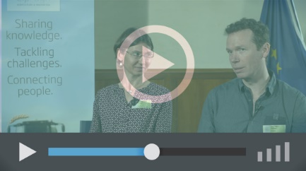
Operational Groups – first experiences | Operational Groups – collaborate to innovate | Innovation Support Services, supporting innovation in EU farming and forestry

https://docs.european-bioplastics.org/publications/pp/EUBP_EuropaBio_PP_Fertilizer_Regulation.pdf
https://docs.european-bioplastics.org/publications/pp/EUBP_EuropaBio_PP_Fertilizer_Regulation.pdf

