Estonian farmer turns grassland grazing into climate solution

Sustainable cattle grazing for biodiversity, healthy soil and carbon capture
The realities of a changing climate have an increasing impact on our environment and on European agriculture and forestry. To build resilience to the effects of climate change, and actively contribute to climate change mitigation, Estonian farmer Airi Külvet is developing sustainable practices for her grazing cattle through a whole-farm approach. “It’s not difficult if you keep in mind the goal: a better soil that will be more sustainable and give a higher yield in the long run.”
Drought, changing rainfall patterns, extreme weather events, pests and diseases and other effects of climate change can seriously affect farm productivity, food production and farmers’ incomes. At Puutsa farm in Estonia, organic cattle farmer Airi Külvet is turning challenges into solutions, applying sustainable agricultural practices to benefit her farm business and her animals, and to make an active, positive impact on the environment and climate.
Airi manages a 300 ha organic cattle farm with mainly grassland. Her cattle are 100% grass-fed. The farm’s grazing system helps to restore the soil, enhance biodiversity, and support an efficient nutrient balance. Airi explains: “I apply a rotational grazing system on my farm, based on the Savory method and complemented with information from other European experts in regenerative agriculture. At the same time, I try to adapt my practices to the Estonian climate and to our soil and vegetation.” Airi uses IT solutions to plan the grazing rotations and monitor the structure and nutrient balance of her grassland soils. Applying composted manure helps to restore the soil and enrich it with soil organic matter. She is currently looking into different composting methods and is experimenting with direct seeding of cereals into grassland, and options for no-till cereal production in organic farming.
When managed correctly, these practices help to boost biodiversity and store carbon in the soil, which contributes to reducing greenhouse gas emissions and avoiding nutrient losses. “It’s a natural cycle. If you want to improve the soil, you have to get animals on it in one way or another, if possible. And it’s not difficult if you keep in mind the goal: a better soil that will be more sustainable and will ultimately still give a higher yield in the long run.”
By sharing results and experiences with other farmers, Airi helps to make the benefits of these practices more widely known. “For me, it is important to preserve our natural environment and highlight the important role of grazing animals in the ecosystem. Grazing is a very traditional way of production. The less work you do that uses fossil fuels, the better for the climate and for our wallet.”
Airi actively participates in research projects and innovative collaboration projects with other farmers. As Estonia’s Network Manager for the EU-funded thematic network BovINE, she helps disseminate good practices across Europe. “My involvement in BovINE has helped me to actively discuss good practices, such as the benefits of assessing newborn calf health and cattle welfare. It has broadened my horizon, from learning about environmental issues to beef prices on the world market. It has also made me realise that Estonia has good pedoclimatic conditions for beef production and that we are already implementing many good practices, such as multi-species swards.”

Airi is also the founder of the Grassfed Cattle Quality Scheme, which involves around 77 other farmers, and introduces environmentally friendly beef cattle farming across Estonia. “Through information days and farm visits, ideas are shared and the principles of herding are slowly being adopted. While each new method takes some time to be taken up, and some farmers fear that it will require more work, it helps to explain that portion grazing is simply a forgotten traditional method of grazing cattle that has been around for centuries, with good results for animals and climate.”

Background information

Airi Külvet participated in 3 EIP-AGRI Focus Groups related to climate change: High Nature Value – farming profitability, Nutrient recycling and Sustainable beef production systems.

Airi is the Network Manager for the EU-funded BovINE thematic network (www.bovine-eu.net), which focuses on improving European beef farming resilience and sustainability. Based on her extensive expertise, Airi contributes good practices to BovINE’s freely accessible Knowledge Hub (https://hub.bovine-eu.net).

Project information
Contact:
Airi Külvet +372 53424274 - airi@liivimaalihaveis.ee

More information:

- More information on the Puutsa farm website: http://puutsa.ee/et
- Airi was one of the winners of the WWF Baltic Sea Farmer of the year award in 2021: https://www.wwfbalticfarmer.org/project/airi-kulvet-2/

EIP-AGRI contact
Ina Van Hoye
Communication manager Support Facility ‘Innovation & Knowledge exchange | EIP-AGRI’
ina.vanhoye@eip-agri.eu

+32 486 90 77 43

Project photos
Click on the pictures to download the high resolution versions. The pictures are free for use, please mention the copyright.

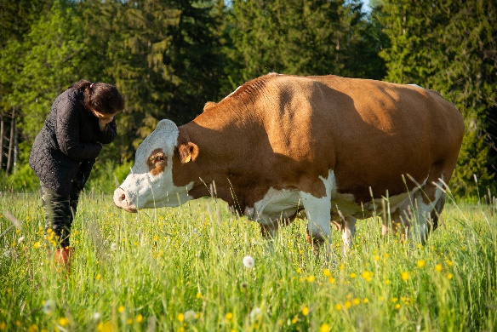 | 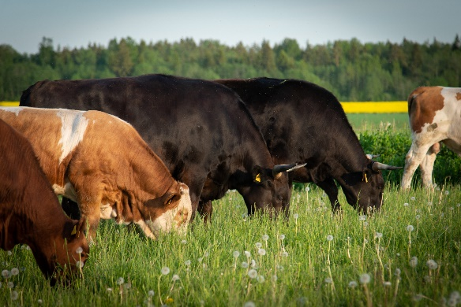
Organic farmer Airi Külvet develops sustainable practices for her grazing cattle through a whole-farm approach. Airi: “It’s not difficult if you keep in mind the goal: a better soil that will be more sustainable and will ultimately still give a higher yield in the long run.” © Airi Külvet / Puutsa Farm | Sustainable grazing practices can help to boost biodiversity and store carbon in the soil, which contributes to reducing greenhouse gas emissions and avoiding nutrient losses. Airi Külvet: “It’s a natural cycle. If you want to improve the soil, you have to get animals on it in one way or another, if possible.” © Airi Külvet / Puutsa Farm
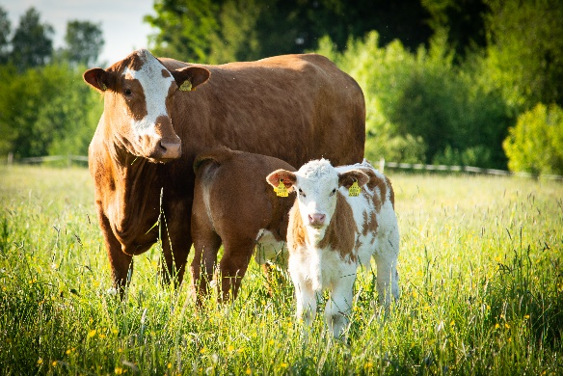 | 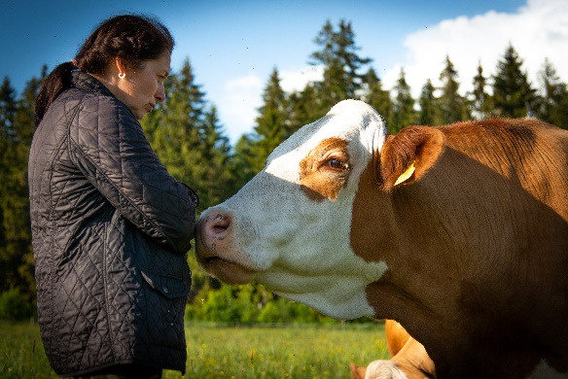
Estonian farmer Airi Külvet: “Grazing is a very traditional way of production. The less work you do that uses fossil fuels, the better for the climate and for our wallet.” © Airi Külvet / Puutsa Farm | By sharing results and experiences with other farmers, Airi helps to make the benefits of sustainable practices more widely known. “Each new method takes some time to be taken up, but it helps to explain that portion grazing has been around for centuries, with good results for animals and climate.” © Airi Külvet / Puutsa Farm

More information on climate change

EIP-AGRI activities on climate change

EIP-AGRI Focus Groups
- Agroforestry: woody vegetation
- Bee health
- Carbon storage in arable farming
- Circular horticulture
- Ecological Focus Areas
- Fertiliser efficiency
- Frost damage
- Grazing for Carbon
- High Nature Value farming
- IPM for Brassica
- IPM for soil-borne diseases
- Mixed farming systems
- Moving from source to sink in arable farming
- New forest practices & climate change
- Non-chemical weed management
- Nutrient recycling
- Organic farming - optimising arable yields
- Profitability of permanent grassland
- Reducing emissions in cattle farming
- Renewable energy on the farm
- Soil organic matter
- Soil salinisation
- Sustainable mobilisation of forest biomass
- Tropical crops
- Water & agriculture: adaptive strategies at farm level
- Nature-Based Solutions for water management under climate change

EIP-AGRI events
- EIP-AGRI Workshop: 'Connecting innovative projects: Water & Agriculture'
- EIP-AGRI Workshop: 'Cropping for the future: networking for crop rotation and crop diversification'
- EIP-AGRI Workshop 'Opportunities for Agriculture and Forestry in the Circular Economy'
- EIP-AGRI Workshop: Opportunities for farm diversification in the circular bioeconomy
- EIP-AGRI workshop 'Organic is Operational'
- EIP-AGRI workshop ‘New value chains from multifunctional forests’
- Agri-Innovation summit 2019
- EIP-AGRI Workshop: Shaping the EU mission 'Caring for soil is caring for life'
- EIP-AGRI Workshop: 'Towards carbon-neutral agriculture'
- EIP-AGRI Workshop: 'Tools for environmental farm performance'
- EIP-AGRI Seminar: 'Healthy soils for Europe: sustainable management through knowledge and practice'

EIP-AGRI publications
- EIP-AGRI Brochure Sustainable livestock farming
- EIP-AGRI Brochure Innovation for European forestry
- EIP-AGRI Brochure Water and Agriculture
- EIP-AGRI Brochure Soil organic matter matters
- EIP-AGRI Brochure 'Climate-smart agriculture: Solutions for resilient farming and forestry'I

EIP-AGRI Videos
- AGRI challenge: soil fertility through carbon storage
- AGRI challenge: New ways to deal with soil salinisation in farming
- AGRI challenge: soil salinisation
- Agroecology clip
- AGRI challenge: Crop diversification in grassland
- AGRI challenge: Monitoring bee health
You can also take a look at the Climate-change playlist on the EIP-AGRI Youtube Channel. .

Inspirational ideas from the network
- A kit to improve soil biological activity (France)
- Agroecology for sustainable soils (France)
- Using data to manage environmental impact of livestock farming (France)
- Agroforestry- a win-win for nature and the farmer (Germany)
- Climate-friendly practices (DE, IT, SE)
- Cutting atmospheric carbon: a central role for soils (France)
- Changing weather conditions force olive farmers to start with pest management (Italy)
- Farmers leading implementation of sustainable water management solutions (Ireland)
- Irish Operational Group runs smallscale on-farm biogas plants to reduce climate change impact (Ireland)
- Dealing with water scarcity (Spain)
- Grazing management with a heart for soil health (UK)
- Increasing farm profitability while cutting carbon emissions, a toolkit developed by farmers for farmers (UK)
- Inspiration across borders: Dutch dairy farmers visit Irish farms (Netherlands and Ireland)
- Looking after the soil to bring life and carbon back (Austria)
- Mixed farming in the Aveyron river basin (France)
- Pasture for pollinators (UK)
- Preventing forest fires in Portugal (Portugal)
- Pulses- superfood for the future (EU)
- Sprinkler systems as protection against frost damage (Poland)

The EIP-AGRI network supports climate change by promoting and sharing innovative practices. Read the EIP-AGRI Newsletter from January 2020 which was dedicated to climate change. For all relevant EIP-AGRI network activities see the Climate change ‘spotlight page’.

Horizon 2020 multi-actor projects working on climate change

- CIRCULAR AGRONOMICS - Efficient Carbon, Nitrogen and Phosphorus cycling in the European Agri-food System and related up- and down-stream processes to mitigate emissions: website - CORDIS
- CONSOLE - CONtract SOLutions for Effective and lasting delivery of agri-environmental-climate public goods by EU agriculture and forestry: CORDIS (05/2019-04/2022)
- Contracts2.0 - Co-design of novel contract models for innovative agri-environmental-climate measures and for valorisation of environmental public goods: CORDIS (05/2019-04/2023)
- EFFECT - Environmental public goods From Farming through Effective Contract Targeting: website - CORDIS (05/2019-04/2023
- NEURICE - New commercial EUropean RICE (Oryza sativa) harbouring salt tolerance alleles to protect the rice sector against climate change and apple snail (Pomacea insularum) invasion: website - CORDIS (03/2016-02/2020)
- Nutri2Cycle - Transition towards a more carbon and nutrient efficient agriculture in Europe: website - CORDIS (10/2018-09/2022)
- STARGATE - reSilienT fARminG by Adaptive microclimaTe managEment: CORDIS (10/2019-09/2023)
- TomGEM - A holistic multi-actor approach towards the design of new tomato varieties and management practices to improve yield and quality in the face of climate change: website - CORDIS (03/2016-02/2020)
- FAirWAY - Farm systems that produce good Water quality for drinking water supplies: website - CORDIS (06/2017-05/2021)
- WATERPROTECT - Innovative tools enabling drinking WATER PROTECTion in rural and urban environments: website - CORDIS (06/2017-05/2020)
- InnoForESt - Smart information, governance and business innovations for sustainable supply and payment mechanisms for forest ecosystem services: website - CORDIS (11/2017-10/2020)
- SINCERE - Spurring INnovations for Forest ECosystem SERvices in Europe: website - CORDIS (01/2018-12/2021)

More relevant multi-actor projects and thematic networks here.
Multi-actor projects are projects in which end users and multipliers of research results such as farmers and farmers’ groups, advisers, enterprises and others, are closely cooperating throughout the whole research project period.
Thematic networks are multi-actor projects which collect existing knowledge and best practices on a given theme to make it available in easily understandable formats for end-users such as farmers, foresters, advisers etc.

Operational Groups working on climate change

327 Operational Groups working on climate change are available in the EIP-AGRI Operational Groups database (update July 2022)

- Austria: 5
- Belgium: 1
- Croatia: 4
- Finland: 1
- France: 23
- Germany: 33
- Hungary: 3
- Ireland: 12
- Italy: 84
- Latvia: 1
- Lithuania: 3
- The Netherlands: 47
- Portugal: 7
- Slovenia: 16
- Spain: 74
- Sweden: 3
- UK: 10

The CAP of the Future
The reform of the Common Agricultural Policy (2023-2027) was formally approved end November 2021. Find all information on the new CAP on the European Commission website.

Innovation & knowledge exchange | EIP-AGRI
The European Innovation Partnership 'Agricultural Productivity and Sustainability' (EIP-AGRI) was launched in 2013 by the European Commission in a bid to promote rapid modernisation of the sectors concerned, by stepping up innovation efforts. The EIP-AGRI aims to foster innovation in the agricultural and forestry sectors and in rural areas by bringing research and practice closer together – in research and innovation projects as well as via the EIP-AGRI network. Also grassroots ideas from farmers get developed into innovations through the so-called Operational Group innovation projects. The EIP-AGRI aims to streamline, simplify and better coordinate existing instruments and initiatives, and complement them with actions where necessary. More information at the ‘About section’ of the EIP-AGRI website.

EIP-AGRI Operational Groups
- 98 Rural Development Programmes provide support to innovative EIP Operational Group projects *
- Over 3200 Operational Groups are planned to be established under the approved RDPs (2014 – 2020)
- More than 2400 Operational Groups projects have been selected for funding and are currently ongoing (or already finished)*. Member States will still start more Operational Group projects which may run until 2025 (under current transitional rules for EU rural development programmes). Find information on all of them in the EIP-AGRI database.

* Information officially submitted to the European Commission by RDP Managing Authorities (November 2020)

EIP-AGRI Operational Groups are groups of people who work together in an innovation project funded by Rural Development Programmes (RDPs). They bring together partners with complementary knowledge. The composition of the group will vary according to the theme and specific objectives of each project. Farmers, advisors, scientists, businesses or other relevant partners work together to find practical solutions for specific problems or opportunities for European farmers and foresters. Farmers and foresters need to cooperate throughout the project to ensure that the innovative solutions are practical and likely to be quickly applied in the field. Read the basic principles. Innovation support services (including advisors with a focus on innovation), and in particular innovation brokering, can therefore play a crucial role in getting worthwhile projects off the ground by facilitating contacts.

Check out the section on the EIP-AGRI website dedicated to 'Operational Groups', including:
- more than 2400 Operational Groups available in the database
- detailed information on how to set up Operational Groups, on supporting networks and relevant EIP-AGRI seminars and workshops
- links to results and contact details of ongoing Operational Groups in the EIP-AGRI database
- a list of all RDP Managing Authorities

EIP-AGRI videos
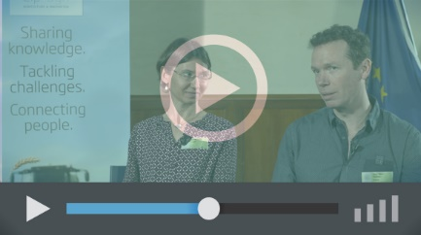
Operational Groups – first experiences | Operational Groups – collaborate to innovate
 | 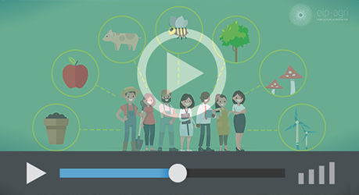
Innovation Support Services, supporting innovation in EU farming and forestry | EIP-AGRI Focus Groups, sharing knowledge to inspire innovation
AKIS: building effective knowledge flows across Europe

EIP-AGRI, 7 years of innovation

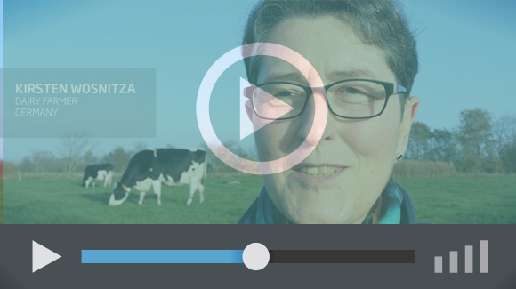 |  | The enthusiasm of the EIP-AGRI network members is essential to the success of the EIP-AGRI, and in ensuring that everyone can benefit. Watch this EIP-AGRI video to hear researchers, farmers, advisors, Managing Authorities and National Rural Networks explain how the EIP-AGRI has helped them over the past 7 years.
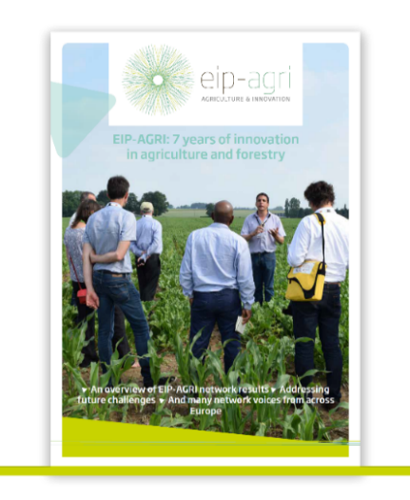 | Since 2013, the EIP-AGRI has been promoting interactive innovation to make EU agriculture and forestry more sustainable, productive, and fit for the future. This report shows how the EIP-AGRI network has grown into a thriving network. Read the report

