Substituting plant protection products in fruit production

Spanish Operational Group project lists alternative strategies for stone fruit, berries and table grapes

Fruit growers are faced with many challenges, they need to maintain a competitive yield while respecting EU regulations limiting the use of plant protection products (PPPs) and their impact on the environment. A Spanish Operational Group is developing a list of alternative strategies for stone fruit, berries and table grapes which can be applied instead of PPPs.
Spanish Operational Group ‘FruitCare’ was created in 2020 and aimed to establish PPP substitution programmes for fruit producers. The project coordinator, Esther Arias (PCTAD) tells us “The main objective of this project is to safeguard the competitiveness of the fruit-producing sector in Spain and ensure minimum impact on the environment. It is important to anticipate the adaptation of crop production to the new European public health requirements.” The Operational Group was set up to design and promote sustainable, non-chemical, preventive, and curative production practices as alternatives to PPPs, tailored to characteristics and requirements of each crop and geographical area.
A range of partners are involved, including farmers and agricultural cooperatives. “When farmers participate in the project, this guarantees the hands-on and close-to-market approaches, which help to find solutions and alternatives that meet the challenges addressed by this kind of projects” – emphasises Javier Arizmendi from ZERYA and technical advisor to the Operational Group.
The first stage of the project was to classify the active substances which were on the European Food Safety Authority list according to function, pathogen/pest, and crop. Then, the partners evaluated the impact of the suppression of each PPP. “Farmers participating in the project were interviewed about their concerns regarding future restrictions on the use of the active ingredients they use” – says Javier, and the partners also carried out a review of alternatives in the market which could serve as substitutes, “We identified both preharvest and postharvest targets among the targeted ‘candidates for substitution’ CfS.”
Next, the partners defined the technical aspects of the alternatives for each of the PPPs. Javier Arizmendi explains “All of the strategies are related to a lower environmental impact including biocontrol treatments in the field, stimulation of plant resistance, application of postharvest technologies that help to maintain the quality of the fruit and increase its shelf life (e.g. non-chemical quarantine treatments). The strategies also consider impact on human health - from the farmer to consumer.”
The partners carried out a comparative study, collecting data and results from field trials. The study considers the socio-economic impact of the strategies, allowing them to determine the real consequences of the suppression of active ingredients, as well as the suitability of the alternative strategies proposed, in each crop.
Based on the outcomes of the project, the partners have designed and created ‘Dissemination cards’ for each of the PPPs. Javier Arizmendi explains, “The cards explain concisely which alternative processes or methods can be used instead of the product. Furthermore, we carried out a study about the insect populations on each of the test plots, comparing the density and biodiversity of species at the end of the last season. This study has allowed us to assess the direct impact on insects – both pathogenic and beneficial, related to the two different agricultural models tested. The cards were distributed to all the farming members of the Group involved in the project and can also be downloaded on the FruitCare website.

Background information

Project information

Contact:
Javier Arizmendi Ruiz – COO - info@fruitcare.eu
José A. López – jal@fita-aragon.es

More information:
- Link to Operational Group page on the EIP-AGRI website

- https://twitter.com/fruit_CARE/status/1382244861718454273
- https://www.linkedin.com/company/fruitcare/
- https://www.facebook.com/GOfruitCARE

EIP-AGRI contact
Ina Van Hoye
Communication manager Support Facility ‘Innovation & Knowledge exchange | EIP-AGRI’
ina.vanhoye@eip-agri.eu
+32 486 90 77 43

Project photos
The pictures are free for use, please mention the copyright.

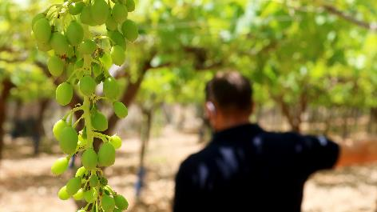 | 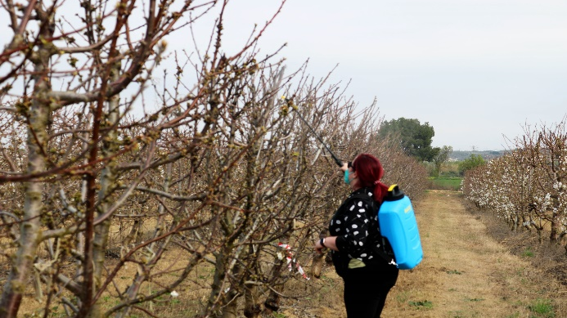
Javier Arizmendi from ZERYA and technical advisor to the Operational Group explains “All of the strategies are related to a lower environmental impact including biocontrol treatments in the field, stimulation of plant resistance, application of postharvest technologies that help to maintain the quality of the fruit and increase its shelf life (e.g. non-chemical quarantine treatments). The strategies also consider impact on human health - from the farmer to consumer.” © FRUITCARE

More information on sustainable fruit production

Farm to Fork: New rules to reduce the risk and use of pesticides in the EU
Although PPPs can protect plants from being destroyed by diseases and infestations, at the same time they can have detrimental effects on the soil, water, air, and biodiversity as well as on non-target organisms, animals, and human health.

In 2015, EFSA (the European Food Safety Authority) published an extended draft list of 77 ‘candidates for substitution’ (CfS) – active substances which must be reduced in plant protection. These were substances which pose a specific risk, or it was considered that pathogens or pests that they control can be addressed using non-chemical or preventive methods. This list led to a new national policy limiting their use and it also spurred manufacturers to withdraw certain products from the market. Production systems, therefore, need to evolve, to reduce the reliance on pesticides, find alternative solutions and implement more integrated and sustainable approaches.

In June 2022, the European Commission proposed new rules to reduce the use and risk of pesticides in the EU, delivering on the Farm to Fork Strategy objective of a fair, healthy and environmentally respectful food system. As part of the Farm to Fork strategy under the Green Deal, the European Union targets a 50% reduction of chemical pesticides by 2030.

More information: https://ec.europa.eu/commission/presscorner/detail/en/qanda_22_3694

EIP-AGRI activities on pest management
The EIP-AGRI Focus Group ‘Sustainable ways to reduce the use of pesticides in pome and stone fruit production’ addressed the question of how alternative methods can reduce the use of pesticides in pome and stone fruits and support the productivity of the sector in a sustainable way. In June 2022 the 20 EIP-AGRI Focus Group experts held their second meeting. The Focus Group report is scheduled to be ready in Autumn 2022.

EIP-AGRI Focus Groups on pest management
- Diseases and pests in viticulture
- Non-chemical weed management in arable cropping systems
- Optimising profitability of crop production through Ecological Focus Areas
- Integrated Pest Management (IPM) - Focus on Brassica species
- IPM practices for soil-borne diseases suppression in vegetables and arable crops
- Pests and diseases of the olive tree

EIP-AGRI publications
- EIP-AGRI Brochure IPM for Brassica
- EIP-AGRI Factsheet on IPM for Brassica
- EIP-AGRI Factsheet Soil-borne Diseases
- EIP-AGRI Factsheet on Diseases and pests in viticulture
- AGRI Challenge video: Non-chemical weed management in arable cropping systems
- AGRI Challenge video: Pests and diseases in olive trees in Mediterranean regions

EIP-AGRI inspirational ideas on pest management
- Inspirational ideas: Vineyard app for plant protection (ES)
- Inspirational ideas: Crop health and pesticide resistance (UK)
- Inspirational ideas: Fighting grapevine trunk diseases (ES)
- Inspirational ideas: Dealing with pests from the air (FR)
- Inspirational ideas: Smart sensors to better understand plant growth (NL, Serbia)
- Inspirational ideas: Ideas for IPM (NL, SI, CH)
- Inspirational ideas: Changing weather conditions force olive farmers to start with pest management (IT)
- Inspirational ideas: Olive groves and drones - science fiction turned reality (ES)
- Inspirational ideas: Combatting weeds with non-chemical alternatives (PT)
- Inspirational ideas: A mobile app to monitor pests and diseases in Umbria, Italy (IT)

Horizon 2020 multi-actor projects working on pest management

INNOSETA - Accelerating Innovative practices for Spraying Equipment, Training and Advising in European agriculture through the mobilization of Agricultural Knowledge and Innovation Systems: website - CORDIS (05/2018-04/2021)

IWMPRAISE - Integrated Weed Management: PRActical Implementation and Solutions for Europe: website - CORDIS (06/2017-05/2022)
- EMPHASIS - Effective Management of Pests and Harmful Alien Species -Integrated Solutions: website - CORDIS (03/2015-02/2019)
- nEUROSTRESSPEP - Novel biocontrol agents for insect pests from neuroendocrinology: website - CORDIS (06/2015-05/2019)
- VIROPLANT - Virome NGS analysis of pests and pathogens for plant protection: website - CORDIS (05/2018-04/2021)
- FF-IPM - In-silico boosted, pest prevention and off-season focused IPM against new and emerging fruit flies ('OFF-Season' FF-IPM): website - CORDIS (09/2019-08/2023)
- PRE-HLB- PREVENTING HLB EPIDEMICS FOR ENSURING CITRUS SURVIVAL IN EUROPE: CORDIS (06/2019-05/2023)
- PestNu - Field -testing and demonstration of digital and space based technologies with agro-ecological and organic practices in systemic innovation: website – CORDIS (01/10/2021-30/09/2024)
- EUFRUIT – the European Fruit Network: website – CORDIS (01/03/2016 – 28/02/2019)
More Horizon projects working on pest management are available at the EIP-AGRI website.
Multi-actor projects are projects in which end users and multipliers of research results such as farmers and farmers’ groups, advisers, enterprises and others, are closely cooperating throughout the whole research project period.
Thematic networks are multi-actor projects which collect existing knowledge and best practices on a given theme to make it available in easily understandable formats for end-users such as farmers, foresters, advisers etc.

Operational Groups working on pest management

414 Operational Groups working on pest management are available in the EIP-AGRI Operational Groups database (update June 2022)

- Austria: 10
- Belgium: 9
- Bulgaria: 1
- Croatia: 2
- Finland: 3
- France: 41
- Germany: 40
- Hungary: 3
- Ireland: 5
- Italy: 92
- Latvia: 4
- Lithuania: 4
- The Netherlands: 46
- Portugal: 34
- Slovenia: 9
- Spain: 83
- Sweden: 6
- UK: 22

The CAP of the Future
The reform of the Common Agricultural Policy (2023-2027) was formally approved end November 2021. Find all information on the new CAP on the European Commission website.

Innovation & knowledge exchange | EIP-AGRI
The European Innovation Partnership 'Agricultural Productivity and Sustainability' (EIP-AGRI) was launched in 2013 by the European Commission in a bid to promote rapid modernisation of the sectors concerned, by stepping up innovation efforts. The EIP-AGRI aims to foster innovation in the agricultural and forestry sectors and in rural areas by bringing research and practice closer together – in research and innovation projects as well as via the EIP-AGRI network. Also grassroots ideas from farmers get developed into innovations through the so-called Operational Group innovation projects. The EIP-AGRI aims to streamline, simplify and better coordinate existing instruments and initiatives, and complement them with actions where necessary. More information at the ‘About section’ of the EIP-AGRI website.

EIP-AGRI Operational Groups
- 98 Rural Development Programmes provide support to innovative EIP Operational Group projects *
- Over 3200 Operational Groups are planned to be established under the approved RDPs (2014 – 2020)
- More than 2400 Operational Groups projects have been selected for funding and are currently ongoing (or already finished)*. Member States will still start more Operational Group projects which may run until 2025 (under current transitional rules for EU rural development programmes). Find information on all of them in the EIP-AGRI database.

* Information officially submitted to the European Commission by RDP Managing Authorities (November 2020)

EIP-AGRI Operational Groups are groups of people who work together in an innovation project funded by Rural Development Programmes (RDPs). They bring together partners with complementary knowledge. The composition of the group will vary according to the theme and specific objectives of each project. Farmers, advisors, scientists, businesses or other relevant partners work together to find practical solutions for specific problems or opportunities for European farmers and foresters. Farmers and foresters need to cooperate throughout the project to ensure that the innovative solutions are practical and likely to be quickly applied in the field. Read the basic principles. Innovation support services (including advisors with a focus on innovation), and in particular innovation brokering, can therefore play a crucial role in getting worthwhile projects off the ground by facilitating contacts.

Check out the section on the EIP-AGRI website dedicated to 'Operational Groups', including:
- more than 2400 Operational Groups available in the database
- detailed information on how to set up Operational Groups, on supporting networks and relevant EIP-AGRI seminars and workshops
- links to results and contact details of ongoing Operational Groups in the EIP-AGRI database
- a list of all RDP Managing Authorities

EIP-AGRI videos
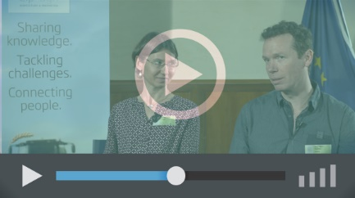
Operational Groups – first experiences | Operational Groups – collaborate to innovate
 | 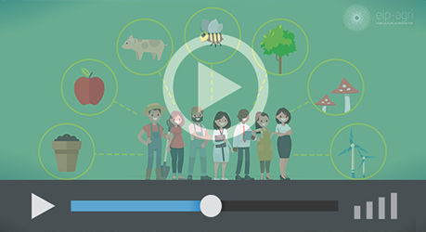
Innovation Support Services, supporting innovation in EU farming and forestry | EIP-AGRI Focus Groups, sharing knowledge to inspire innovation
AKIS: building effective knowledge flows across Europe

EIP-AGRI, 7 years of innovation

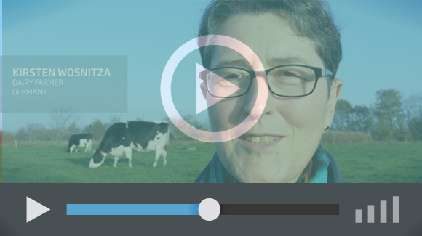 |  | The enthusiasm of the EIP-AGRI network members is essential to the success of the EIP-AGRI, and in ensuring that everyone can benefit. Watch this EIP-AGRI video to hear researchers, farmers, advisors, Managing Authorities and National Rural Networks explain how the EIP-AGRI has helped them over the past 7 years.
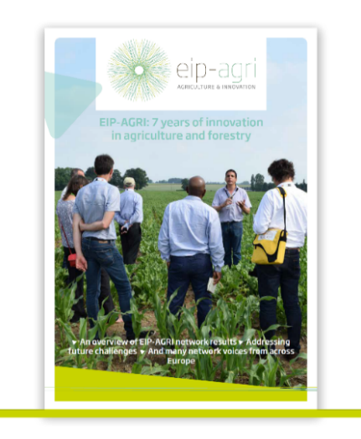 | Since 2013, the EIP-AGRI has been promoting interactive innovation to make EU agriculture and forestry more sustainable, productive, and fit for the future. This report shows how the EIP-AGRI network has grown into a thriving network. Read the report

