Digital tool to build up a picture of soil fertility
Digital solution to help advisors and farmers create sustainable nutrient management plans

“In Ireland, only 15-20% of soils are at optimum soil fertility” says Tim Hyde, Environment Specialist at Teagasc, Irish Agriculture and Food Development Authority. For the past 5 years, advisors and farmers in Ireland have been able to use a digital online tool to draw up individual and sustainable Nutrient Management Plans to optimise soil fertility.

The Teagasc Nutrient Management Planning (NMP) Online tool was created in 2016. It is a digital platform available to agri-professionals who work with farmers to optimise soil fertility. Combining the advisor’s expert knowledge with data from the online platform, this tool allows to create detailed and individualised nutrient management plans to optimise fertilisation and bring soils up to optimum fertility. The data powering the online tool is from the latest research and science available on soil fertility on farms across Ireland, available in the Teagasc Green Book.

The advisor first takes soil samples from the farm and analyses them. Data from the soil samples are run through the platform, together with other farm information such as type of crops, animal numbers, stocking rate, … The digital platform then provides a full picture of the soil fertility on farm and at field level, showing the nutrient demand of the crops per field. The advisor and farmer then draw up a Nutrient Management Plan tailored to the farmer’s needs. Through the platform, advisors can access the latest aerial imagery and mapping and can generate user-friendly reports and maps.

The online tool is able to efficiently complete complex nutrient calculations, taking into account the regulations from the Nitrates Directive as well as crop requirements. These calculations are based on different parameters such as soil type, current soil fertility and crops being grown. It first addresses the soil pH on the farm and sets out an annual liming plan, a plan to use home-produced organic manures, and, if needed, a roadmap on how and when to build up with chemical fertilisers. In fact, the plan will show what fields need lime, organic manures, N, P and K compounds – the full list of fertilisers for the farm for the year, ensuring that the farm stays within nitrate limits and delivers the best value to the farmer.

Pádraig Foley, technologist at Teagasc says “The digital tool helps target the fields that need the nutrients. Getting the fertiliser out at the right rate, time and place improves the production capacity on the farm, which builds profit and at the same time enhances environmental sustainability of the farm.” Mark Boland, agricultural advisor applying the tool together with farmers, affirms: “The platform provides a key decision support tool for both advisors and farmers when planning for the year ahead.”

Art Murphy, a tillage farmer from Killabeg (South East of Ireland), requests an NMP plan from his advisor every year: “The plan provides me with accurate fertiliser and lime advice based on up-to-date soil samples I have taken. By following the advice from the plan, I am confident that I will achieve consistent yields and quality.”

Teagasc provides agri-professionals with training on how to use the tool, and has made a series of “How to” videos. Pádraig concludes “NMP Online will continue to evolve. It will be updated as Teagasc’s scientists make progress both from an agronomic and an environmental sustainability perspective, it will also change along with policy. We cannot forget the end users. This is where the digital tool makes a difference - at farm level, so it must be easy to interpret and simple to use. The future for NMP Online needs to be mobile.”

Background information
The European Commission (EC) estimates that 60 to 70% of soils EU-wide are not in a good condition, for example due to the decline of organic matter and biodiversity. Soil degradation is costing the EU several tens of billion euros per year and causing considerable losses to natural resources. The EU Soil Strategy for 2030 promotes “practices that sustain and enhance soil health and biodiversity, improve cost efficiency and limit the inputs (e.g. pesticides, fertilisers) needed to maintain yields.” Within the new CAP regulation (article 15), by 2024, Member States will be required to offer digital applications for the sustainable management of nutrients. In some Member States, such as Ireland, this type of tool has already been created and is in use.

The experts from the EIP-AGRI Focus Group ‘Digital tools for sustainable nutrient management’ cover the question ‘Which are the key conditions, functions and technical requirements to develop, promote and facilitate the use of digital applications for farm nutrient management?’ The Focus Group experts have a second meeting on 14-15 June. A Focus Group report will follow this meeting - including a state of play, recommendations, ideas for Operational Groups and research needs on the topic – foreseen to be published end 2022.

Project information
Contact: Padraig Foley Padraig.Foley@teagasc.ie 00353 539171265
- https://www.teagasc.ie/publications/2020/nmp-online-software-for-a-hard-job.php
- https://ec.europa.eu/environment/publications/eu-soil-strategy-2030_en
- CAP regulation: https://eur-lex.europa.eu/legal-content/EN/TXT/?uri=CELEX:32021R2115
- videos
- Teagasc Green Book

EIP-AGRI contact
Ina Van Hoye
Communication manager Support Facility ‘Innovation & Knowledge exchange | EIP-AGRI’
ina.vanhoye@eip-agri.eu
+32 486 90 77 43

Project photos
The pictures are free for use, please mention the copyright.

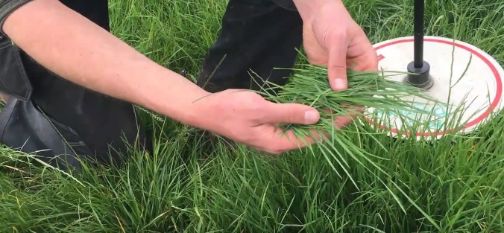 | 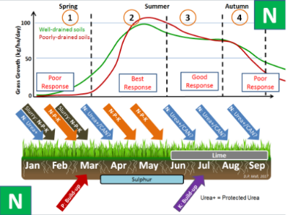
Pádraig Foley, technologist at Teagasc says “The digital tool helps target the fields that need the nutrients. Getting the fertiliser out at the right rate, time and place improves the production capacity on the farm, which builds profit and at the same time enhances environmental sustainability of the farm.” © Teagasc

More information on digital tools & nutrient management

The FaST platform (Farm Sustainability Tool for Nutrients)

The FaST, Farm Sustainability Tool will support EU agriculture and the Common Agricultural policy to advise on fertiliser use. It develops data-based solutions for the sustainable management of nutrients. It is free and open source. This initiative develops the tools for European countries, the countries can then customise with data, algorithms,…

The European Commission’s DG Agriculture and Rural Development, the EU Space Programme (DG DEFIS) and the EU ISA2 Programme (DG DIGIT) support the FaST digital service platform. It will create possibilities for agriculture, environment and sustainability to assist EU farmers, Member State Paying Agencies, farm advisors and developers of digital solutions.

The vision is for the FaST to become a world-leading platform for the generation and re-use of solutions for sustainable and competitive agriculture based on space data (Copernicus and Galileo) and other data public and private datasets.

More information: https://fastplatform.eu/

EIP-AGRI activities

EIP-AGRI networking activities on digital tools and nutrient management

- EIP-AGRI Focus Group ‘Digital tools for sustainable nutrient management’
- EIP-AGRI Focus Group ‘Fertiliser efficiency - Focus on horticulture in open field’
- EIP-AGRI Focus Group ‘Nutrient recycling’

EIP-AGRI publications
- EIP-AGRI Brochure Digital evolution in agriculture – available in English, French, German, Hungarian, Latvian, Romanian, Slovenian
- EIP-AGRI factsheet Digital (r)evolution, with EIP-AGRI scope and links to previous EIP-AGRI events, inspirational ideas, funding opportunities,… related to digitilisation
- The Agrinnovation magazine 2018 focused on digitalisation (available in English and Greek)
- In February 2020 the EIP-AGRI Service Point launched a digitalisation thematic campaign, including a social media campaign #EIPagriDigi to highlight related EIP-AGRI activities and the February 2020 EIP-AGRI newsletter focussing on digitalisation (also available in French, Estonian, Romanian, Slovakian)

Be inspired by digital technologies and innovative projects for the farming and forestry community at the ‘digital agriculture’ section at the EIP-AGRI website and find out how to improve your digital knowledge and skills.

EIP-AGRI inspirational ideas on digital tools and/ or nutrient management
- Improving welfare for cows… and farmers (Denmark)
- Potatoes and automatic weather stations: beating the late blight disease (Estonia)
- Mapped land-use data for farmers and forest managers (EU)
- ICT solutions for agrobiodiversity (EU)
- Saving time and resources with swarm seeding robots (EU)
- Robot versus weeds (EU/ Spain)
- Biovakka, Manure management to produce biogas and nutrients (Finland)
- Dealing with pests from the air (France)
- Digital technologies help fruit growers optimise return (Germany)
- Data-driven technologies increase milk yields and milk quality (Hungary)
- Staying in tune with farm performance (Ireland)
- A mobile app to monitor pests and diseases in Umbria (Italy)
- Fertile Circularity (the Netherlands)
- Agriso (Romania)
- Precision farming in organic production? More efficient weed and fertiliser management for increased productivity (Sweden)
- EU-PLF, the farmers’ perspectives (UK)
- Data sharing through Farmbench (UK)
- Delivering Farm Profitability and Better Environmental Performance (UK)
- Olive groves and drones - science fiction turned reality (Spain)

Horizon 2020 multi-actor projects working on nutrient management
- FATIMA - FArming Tools for external nutrient Inputs and water Management: website - CORDIS (03/2015-02/2018)
- SolACE - Solutions for improving Agroecosystem and Crop Efficiency for water and nutrient use: website - CORDIS (05/2017-04/2022)
- TomRes - a novel and integrated approach to increase multiple and combined stress tolerance in plants using tomato as a model: website - CORDIS (06/2017-11/2020)
- Circular Agronomics - Efficient Carbon, Nitrogen and Phosphorus cycling in the European Agri-food System and related up- and down-stream processes to mitigate emissions: website - CORDIS (09/2018-08/2022)
- NUTRIMAN - Nutrient Management and Nutrient Recovery Thematic Network: website - CORDIS (Thematic network – 10/2018-03/2021)
Multi-actor projects are projects in which end users and multipliers of research results such as farmers and farmers’ groups, advisers, enterprises and others, are closely cooperating throughout the whole research project period.
Thematic networks are multi-actor projects which collect existing knowledge and best practices on a given theme to make it available in easily understandable formats for end-users such as farmers, foresters, advisers etc.

Operational Groups working on nutrient management

42 Operational Groups working on nutrient management are available in the EIP-AGRI Operational Groups database (update 11 May 2022)

- Austria: 4
- Belgium: 1
- Finland: 1
- Italy: 7
- Ireland: 4
- Germany: 9
- The Netherlands: 5
- Spain: 7
- Slovenia: 1
- Sweden: 1
- UK: 2

The CAP of the Future
The reform of the Common Agricultural Policy (2023-2027) has been formally approved end November 2021. Find all information on the new CAP on the European Commission website.

Innovation & knowledge exchange | EIP-AGRI
The European Innovation Partnership 'Agricultural Productivity and Sustainability' (EIP-AGRI) has been launched in 2013 by the European Commission in a bid to promote rapid modernisation of the sectors concerned, by stepping up innovation efforts. The EIP-AGRI aims to foster innovation in the agricultural and forestry sectors and in rural areas by bringing research and practice closer together – in research and innovation projects as well as via the EIP-AGRI network. Also grassroots ideas from farmers get developed into innovations through the so-called Operational Group innovation projects. The EIP-AGRI aims to streamline, simplify and better coordinate existing instruments and initiatives, and complement them with actions where necessary. More information at the ‘About section’ of the EIP-AGRI website.

EIP-AGRI Operational Groups
- 98 Rural Development Programmes provide support to innovative EIP Operational Group projects *
- Over 3200 Operational Groups are planned to be established under the approved RDPs (2014 – 2020)
- More than 2400 Operational Groups projects have been selected for funding and are currently ongoing (or already finished)*. Member States will still start more Operational Group projects which may run until 2025 (under current transitional rules for EU rural development programmes). Find information on all of them in the EIP-AGRI database.

* Information officially submitted to the European Commission by RDP Managing Authorities (November 2020)

EIP-AGRI Operational Groups are groups of people who work together in an innovation project funded by Rural Development Programmes (RDPs). They bring together partners with complementary knowledge. The composition of the group will vary according to the theme and specific objectives of each project. Farmers, advisors, scientists, businesses or other relevant partners work together to find practical solutions for specific problems or opportunities for European farmers and foresters. Farmers and foresters need to cooperate throughout the project to ensure that the innovative solutions are practical and likely to be quickly applied in the field. Read the basic principles. Innovation support services (including advisors with a focus on innovation), and in particular innovation brokering, can therefore play a crucial role in getting worthwhile projects off the ground by facilitating contacts.

Check out the section on the EIP-AGRI website dedicated to 'Operational Groups', including:
- more than 2400 Operational Groups available in the database
- detailed information on how to set up Operational Groups, on supporting networks and relevant EIP-AGRI seminars and workshops
- links to results and contact details of ongoing Operational Groups in the EIP-AGRI database
- a list of all RDP Managing Authorities

EIP-AGRI videos
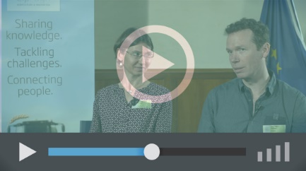
Operational Groups – first experiences | Operational Groups – collaborate to innovate
 | 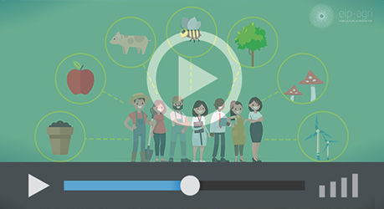
Innovation Support Services, supporting innovation in EU farming and forestry | EIP-AGRI Focus Groups, sharing knowledge to inspire innovation
AKIS: building effective knowledge flows across Europe

EIP-AGRI, 7 years of innovation

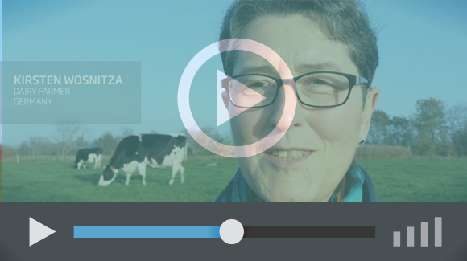 |  | The enthusiasm of the EIP-AGRI network members is essential to the success of the EIP-AGRI, and in ensuring that everyone can benefit. Watch this EIP-AGRI video to hear researchers, farmers, advisors, Managing Authorities and National Rural Networks explain how the EIP-AGRI has helped them over the past 7 years.
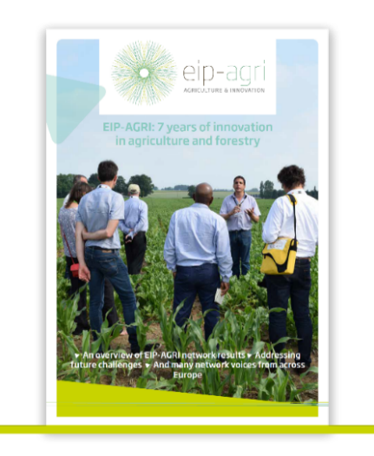 | Since 2013, the EIP-AGRI has been promoting interactive innovation to make EU agriculture and forestry more sustainable, productive, and fit for the future. This report shows how the EIP-AGRI network has grown into a thriving network. Read the report

