Press article

Walloon farmers test pesticide and tillage reduction strategies

Soil living labs working together to obtain healthy soils by 2030
The Walloon Agricultural Research Centre (CRA-W) in Belgium brought together farmers, researchers, advisors and others to set up a living lab testing the simultaneous application of pesticide and tillage reduction strategies. Didier Stilmant, head of the ‘Sustainability, systems and prospectives’ department at CRA-W explains: “After a successful event led by Greenotec, an agricultural association on agroecology and conservation agriculture, and CRA-W,I we created the ABC group (L'Agriculture Biologique de Conservation) as a living lab in 2016. Thereafter this group was supported by the TRANSAE – Interreg and DiverIMPACTS – Horizon 2020 projects. The ABC group proposes systemic innovations on pesticide reduction and reduced tillage, tests them, improves them and promotes them further in the farmer community.”
The living lab ABC group consists of 12 farmers spread over the whole of Wallonia, advisors from Greenotech, researchers and technicians form CRA-W. Didier stresses the importance of the multi-actor approach in their group: “We also have a sociologist on board who helps the group to facilitate exchanges and communication between members, highlight the unsaid things and the points of attention.” The practices tested are strip-till, direct sowing under living mulch, relay cropping of service crops, double density service crops, cultivars mixture...

In this group, there are two types of farmers: organic who would like to reduce tillage intensity and conservation agriculture farmers who would like to decrease their use of pesticides, and more specifically their use of herbicides or fungicides. Vincent Renard is one of the farmers who joined the ABC group. He initially worked with conservation agriculture but returned to ploughing 10 years ago after switching to organic farming. Vincent: "I decided to join the group as I wanted to gain new practical knowledge on how to reduce the intensity of tillage in field crops to improve soil fertility. Controlling weeds is my biggest challenge.”

Each farmer has a contact person from CRA-W and Greenotec. Together they define a specific action plan, that is shared and discussed with the whole group. Each farmer tests the innovative practices on one hectare, and in parallel, a control plot makes it possible to compare the results. The monitoring of the plots takes place over several years, with farmers committing to the tests for three years. Vincent: “For me, it was important to be able to test specific equipment (no-till drill, strip-till) that is not available in the region, to see what it does on my farm.”

Through the group, he was able to meet other farmers and researchers. Vincent:” Without the group, I would never have been able to meet them because they live far away. We are all looking in the same direction, even if we have different points of view. It is by exchanging our personal experiences on the concrete problems we encounter on our farms that we will move forward more quickly. No one has the solution alone, together we learn faster.”

Every year, the group organises two events to present latest results and analyse the efficiency of the practices tested. One of these events takes place in the field. Vincent concludes: “The group is reassuring for me. If I want an opinion, information or help, I can always contact one of the group members.”

Background information

Didier Stilmant was one of the speakers during the EIP-AGRI brokerage event EIP-AGRI brokerage event ‘Get involved in the EU Mission: A Soil Deal for Europe’. He explained how in Wallonie, Belgium, they have already implemented a ‘living labs’ approach to inspire participants on how to set up living labs.

Soil health living labs are defined as user-centred, place-based and transdisciplinary research and innovation ecosystems, which involve farmers, foresters, scientists and other relevant partners in systemic research and co-design, testing, monitoring and evaluation of solutions, in real-life settings, to improve their effectiveness for soil health and accelerate adoption. These living labs are collaborations between multiple partners that operate at regional or sub-regional level and coordinate experiments on several sites within a regional or sub-regional area (or working landscapes).

In the coming years, 100 soil living labs and lighthouses will emerge, focusing on desertification reduction, soil organic carbon stock conservation, erosion prevention,… to obtain healthy soils in Europe by 2030. From 2023 onwards the European Commission will launch as part of the Soil Deal mission, yearly a call under Horizon Europe to potentially interested groups to set up a living lab.

EU Mission: a Soil Deal for Europe
The Mission’s overall goal is to set up 100 living labs and lighthouses to lead the transition toward healthy soils by 2030.
The following specific objectives apply to all types of land use and are backed by quantified targets and measurable indicators:
- Reduce desertification
- Conserve soil organic carbon stocks
- Stop soil sealing and increase re-use of urban soils
- Reduce soil pollution and enhance restoration
- Prevent erosion
- Improve soil structure to enhance soil biodiversity
- Reduce the EU global footprint on soils
- Improve soil literacy in society
Read more

Contact information
- CRA Wallonie, Didier Stilmant: d.stilmant@cra.wallonie.be - +32 81 87 50 00

EIP-AGRI contact
Ina Van Hoye
Communication manager Support Facility ‘Innovation & Knowledge exchange | EIP-AGRI’
ina.vanhoye@eip-agri.eu
+32 486 90 77 43

Project photo
Click on the picture to download the high-resolution version. The pictures are free for use, please mention the copyright below.

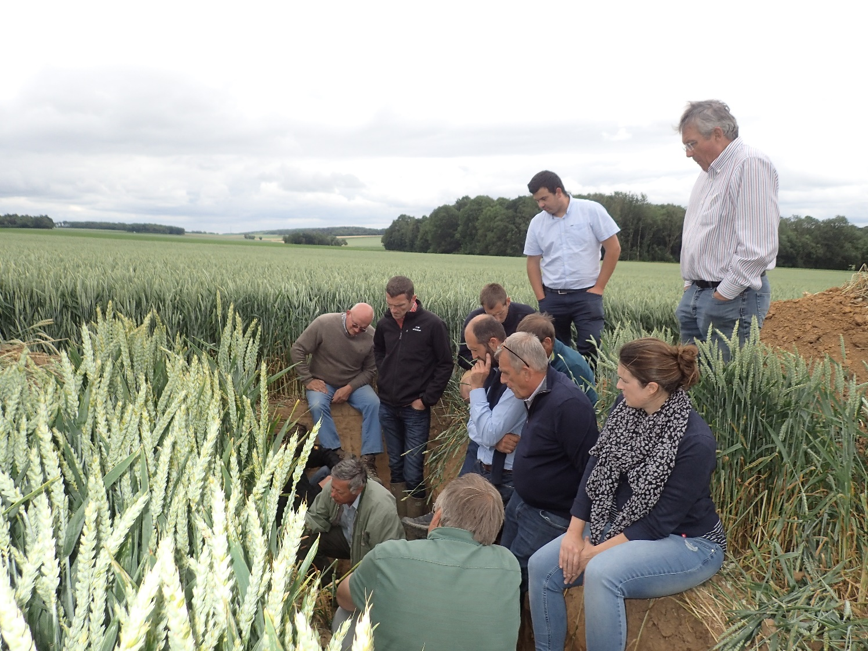
Vincent Renard, one of the farmers who joined the ‘ABC group’: "I wanted to gain new practical knowledge on how to reduce the intensity of tillage in field crops to improve soil fertility. The control of weeds without herbicides is my biggest challenge.” Copyright: CRA-W

More information on living labs

EIP-AGRI activities

EIP-AGRI networking activities on soil health

- On 8-9 June 2022, the EIP-AGRI brokerage event ‘Get involved in the EU Mission: A Soil Deal for Europe’ took place. During this event participants received further information on the EU Mission work programme 2022 and its call and topics. Participants had the opportunity to meet potential partners to apply for a call.
- On 13-14 April 2021, the European Commission, Directorate-General for Agriculture and Rural Development, and the EIP-AGRI Service Point organised the online EIP-AGRI seminar: ‘Healthy soils for Europe: sustainable management through knowledge and practice’. This interactive event was dedicated to exchanging practical solutions to soil health problems and discussing what needs to be done for farms to take them up. Find all presentations, videorecordings of the presentations and background information at the event webpage. The seminar included many examples of member states.
- The EIP-AGRI Workshop: Shaping the EU mission ‘Caring for soil is caring for life’ took place online on 20-21 October 2020. This workshop was organised by the European Commission's Directorate-General for Agriculture and Rural Development and the EIP-AGRI Service Point.

Innovation & knowledge exchange | EIP-AGRI
The European Innovation Partnership 'Agricultural Productivity and Sustainability' (EIP-AGRI) has been launched in 2013 by the European Commission in a bid to promote rapid modernisation of the sectors concerned, by stepping up innovation efforts. The EIP-AGRI aims to foster innovation in the agricultural and forestry sectors and in rural areas by bringing research and practice closer together – in research and innovation projects as well as via the EIP-AGRI network. Also grassroots ideas from farmers get developed into innovations through the so-called Operational Group innovation projects. The EIP-AGRI aims to streamline, simplify and better coordinate existing instruments and initiatives, and complement them with actions where necessary. More information at the ‘About section’ of the EIP-AGRI website.

EIP-AGRI Operational Groups
- 98 Rural Development Programmes provide support to innovative EIP Operational Group projects *
- Over 3200 Operational Groups are planned to be established under the approved RDPs (2014 – 2020)
- More than 2300 Operational Groups projects have been selected for funding and are currently ongoing (or already finished) *. Member States will still start more Operational Group projects which may run until 2025 (under current transitional rules for EU rural development programmes). Find information on all of them in the EIP-AGRI database.

* Information officially submitted to the European Commission by RDP Managing Authorities (November 2020)

EIP-AGRI Operational Groups are groups of people who work together in an innovation project funded by Rural Development Programmes (RDPs). They bring together partners with complementary knowledge. The composition of the group will vary according to the theme and specific objectives of each project. Farmers, advisors, scientists, businesses or other relevant partners work together to find practical solutions for specific problems or opportunities for European farmers and foresters. Farmers and foresters need to cooperate throughout the project to ensure that the innovative solutions are practical and likely to be quickly applied in the field. Read the basic principles. Innovation support services (including advisors with a focus on innovation), and in particular innovation brokering, can therefore play a crucial role in getting worthwhile projects off the ground by facilitating contacts.

Check out the section on the EIP-AGRI website dedicated to 'Operational Groups', including:
- more than 2300 Operational Groups available in the database
- detailed information on how to set up Operational Groups, on supporting networks and relevant EIP-AGRI seminars and workshops
- links to results and contact details of ongoing Operational Groups in the EIP-AGRI database
- a list of all RDP Managing Authorities

EIP-AGRI, 7 years of innovation

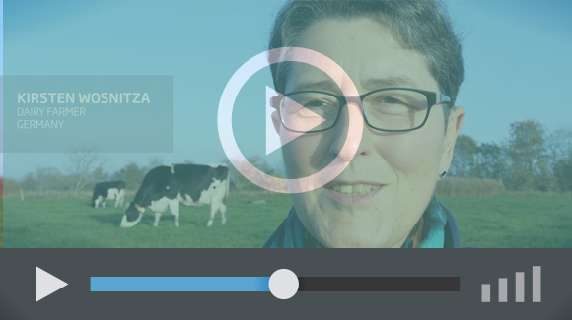 |  | The enthusiasm of the EIP-AGRI network members is essential to the success of the EIP-AGRI, and in ensuring that everyone can benefit. Watch this EIP-AGRI video to hear researchers, farmers, advisors, Managing Authorities and National Rural Networks explain how the EIP-AGRI has helped them over the past 7 years.
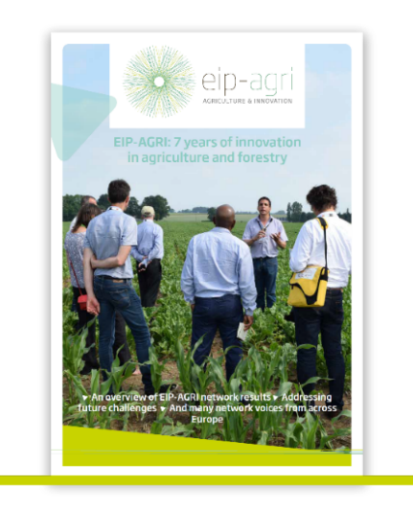 | Since 2013, the EIP-AGRI has been promoting interactive innovation to make EU agriculture and forestry more sustainable, productive, and fit for the future. This report shows how the EIP-AGRI network has grown into a thriving network. Read the report

Definition of Soil health living labs, as mentioned in the Mission Soil Implementation Plan

